Report
Computing AS: second project of the Autumn Term
Space Warfare
Samuel Stark and Bob Sha

Problem Definition

The game we are going to make is a shoot-em-up. We call this game (*) Warfare, with (*) denoting the location. In this genre, you control a vehicle moving around a playfield shooting at enemies while the camera scrolls. You win a stage of the game by getting to a boss enemy, who is stronger and has more health then regular enemies, and killing it. Then you can enter the next stage. In the final stage you meet the strongest boss enemy and after killing it, you win the game.
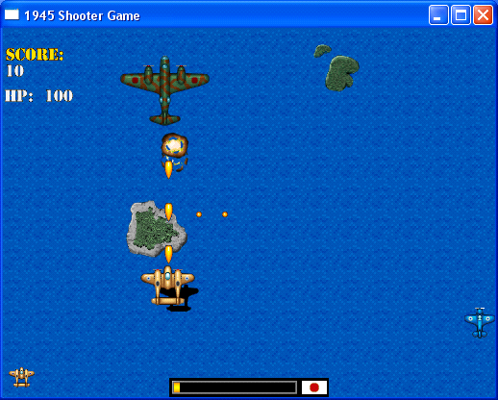
This is a traditional vertical shooter game. You controlled the plane to destroy the Japanese planes, which gives you points.

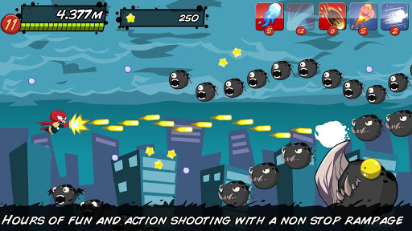
This game scrolls horizontally. It has many interesting features, such as measuring distance traveled and it has various items.

Compared to traditional shoot-em-up games, we want to make some changes to attract people who haven't played them before. What we will do is combine the advantages of different games. One of the changes we would like to make is to add role playing game elements, which means you would gain XP (eXPerience) by killing enemies, which you would keep after you died and would upgrade your ship. This will be one of the special and attractive features of our game.

When we write our questionnaire, we are going to send it to everyone in our school, because most of them are aged from 13-25, which is our target demographic. The questions are easy to understand and general ideas can be collected from them. This will be the only questionnaire that we send, and then we will call the shots from there.

Information collection

We received about 38 pieces of feedback. The questions were:

Have you ever played a shoot-em-up?
Yes: 28
No: 10
In this question, about a quarter of the answers are no. The rest of them are yes. So, many of the respondents have at least tried a shooter game.

If so, how many?

Nearly half of the respondents have tried 3 types of shooter games, which means they are good people to be targeting.

Do you prefer shoot-em-ups that scroll horizontally, vertically, or not at all?
Vertically: 5
Horizontally: 12
No Scrolling: 8
No Preference: 12
This shows people prefer horizontally scrolling games, so ours will scroll horizontally.

Do you prefer short games or long games?
Long games: 13
Short games: 25
Most people like to play games casually. They wouldn’t like to spend hours on the games. This means our game won't have many levels, but there will be a lot of replay value.

Would you prefer a game with a cartoony art style or a realistic art style?
Cartoony: 17
Realistic: 21
The votes were split, which means we can decide what we want. We will pick realistic, because it is very hard to do cartoony graphics without a person who is very good at designing that sort of thing.

Do you like games with role-playing elements?
Yes: 23
No: 15
More people prefer role-playing elements, which will be a good suggestion for us. They will be a feature that makes the game more interesting.

7.What place would you like the game to take place in?
Space: 10
Land: 8
Sea: 5
Other: 13
Space and land were nearly evenly split, and we will choose Space; this is good as it will allow for the enemies to stand out more as pretty much anything will stand out on black. Enemies with green coloring will blend in on land with grass.

Analysis of the questionnaire

We’ll try to make a new kind of shoot-em-up game with different features from others, which will be attractive to the players. The features will make it stand out, and make them attract new people. We decided to make a horizontally scrolling game, because that is what most people want and it also fits on the screen better. The game will be set in space, and the graphics will be realistic instead of being cartoony. We will add role-playing elements into our game. The game is mainly aiming to casual players. It won’t take long to finish the game, but there is a lot of replay value. Because you can decide how to upgrade your vehicle in various ways.

Information Collection about Competitors

We have at least tried 10 shooter games. The games we mentioned before are very good examples of competitors. We also tried some 3D games. And we found out that graphics and attractive features are pretty important to have players. The features which appear quite often are functional items. And we can seldom find a shoot-em-up game with role playing game elements, which means our game will be quite unique.

Feasibility Study

What we need to emphasize is we have no budget. Also,the game will probably be free.

We need to decide if this project is feasible. First, we need to decide what products to use. To actually make the game, we can decide between GameMaker, Unity, or programming the game without any external applications. To create an art style that will look somewhat realistic, I think we should use Unity because GameMaker can only use sprites. Sprites are hard to make look realistic because of the limited number of pixels you can use. Unity also doesn't have any limit on the number of objects/rooms/sprites, while the free version of GameMaker has a limit of 15 for all listed.

We will choose Blender to make 3D modeling, as it’s free

Next, we need an image editor to make textures and such. We'll go with Paint.NET because it’s free. Although we can have better choices of software, we can’t afford it.

For sound, we are going to use Audacity, which is a free, open-source music editor, Hydrogen, which is a free drum synthesiser, and a free trial for RealStrat for the guitar.

Conclusion

Now that we've chosen the products, we can safely say that it will cost us nothing to make this game, as all of the software we have chosen is free. As we all know, if we want to use better software,we will add adverts to the game, which is quite annoying to most of the players. So there will be no adverts on this game. Programming the game will be straightforward, but we still need to make decisions about the game's design before we start programming anything. We will try to add a lot of interesting features. And we will have a further research on different types of shooter games to help us improve our ideas.

